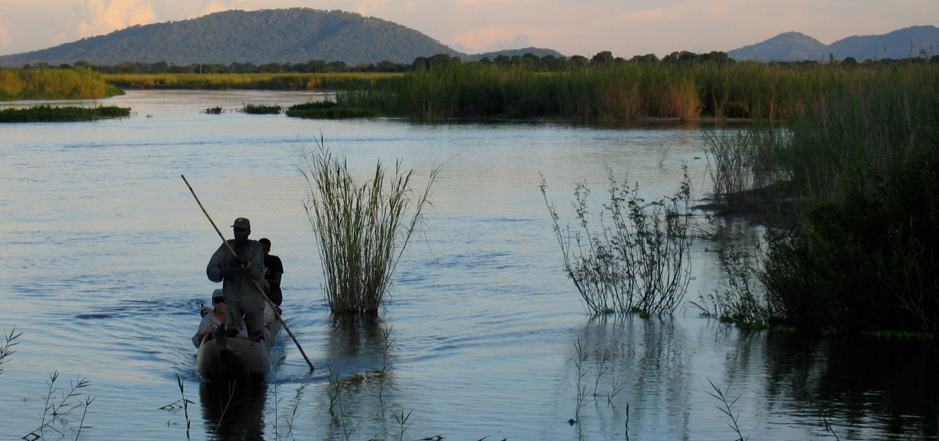
SCHOOL OF GEOGRAPHY
NEW PATTERNS OF MALARIA TRANSMISSION EMERGE IN AFRICA
Dr Mark Smith, Dr Thomas Willis, Dr William James & Dr Mark Trigg
Briefing Note Number 6; 28/08/2020

New continental-scale models of malaria climatic suitability include hydrological processes to estimate the locations of surface water bodies available for mosquito breeding

EXECUTIVE SUMMARY
Malaria transmission is particularly pronounced in Africa where 93% of 228 million global cases of malaria were recorded in 2018 (WHO, 2018). Thanks to huge public efforts to tackle the disease, the malaria map is shrinking. To best distribute often scarce public health resources and design effective, targeted control measures, we need to know exactly where malaria transmission occurs and how this will change in the future.
Changes in patterns of temperature and rainfall will alter the distribution and length of transmission seasons, but there is some uncertainty as to what the actual impact of climate change will be. To address this uncertainty, we need to understand the climatic conditions within which malaria transmission takes place. We can’t just use present-day maps of malaria as we have eliminated transmission from otherwise suitable areas.
Previous models of malaria climatic suitability in Africa used well established temperature ranges alongside monthly rainfall as an approximation of standing water availability for mosquito breeding. However, the use of rainfall ignores hydrological processes that redistribute and alter the water volumes available for mosquito breeding. We showed that predictions of malaria suitability are very sensitive to the exact rainfall threshold used. Working with scientists from Universities of Lincoln, Tokyo, Aberystwyth and the European Commission Joint Research Centre, we coupled a continental-scale hydrological model with a model of malaria climatic suitability to create new maps of present day malaria suitability and model how this will change over the next century.
Our new maps present a much more complex pattern of hydro-climatic suitability for malaria transmission that highlights river corridors as potential year-round foci for transmission, which is important as that’s where many people live. While we see very little change in the total suitable area by 2100, the projected location of those suitable areas changes substantially. Projected aridity-driven decreases in Botswana and Mozambique in rainfall-based models are no longer observed when a hydrological model is used, while projected decreases in stability across much of West Africa are more pronounced. We now see a substantial reduction in suitability in South Sudan and a more complex pattern of increased malaria transmission suitability across South Africa, following the major river corridors.
PROJECT DETAILS
Mosquitoes require bodies of standing water to lay their eggs. In existing continental-scale malaria suitability models this water is represented using rainfall as an approximation. Instead, in collaboration with researchers from the European Commission Joint Research Centre, we used the Lisflood hydrological model to represent the variable infiltration, evaporation and transfer of water through river systems. We applied this model to the whole of Africa using daily temperature and rainfall information from seven Global Climate Models. We then simulated the changing hydro-climatic malaria suitability across the continent up to 2100 using a high-emission scenario.
When hydrological processes are incorporated, a new picture of malaria hydro-climatic suitability emerges. River corridors become highlighted as potential foci for malaria transmission, extending beyond the range previously considered climatically suitable (e.g. over the course of the Nile). That is not to say that malaria is present in these places – it may have been successfully eradicated – just that the climate there is suitable. These estimates are supported by historical observations of malaria outbreaks in these areas.
Hydro-climatic-suitability for malaria in Africa today.
Looking into the future, we don’t see much change in the total area suitable for malaria transmission by 2100, even under an extreme global warming scenario. However, compared with previous rainfall-based estimates, we see a larger geographical shift in areas that are suitable and the pattern of that shift is very different. Again, that doesn’t mean that these areas will experience higher levels of malaria transmission, just that the climate will become more suitable and that we should focus our intervention strategies accordingly.
As in previous models, we see a temperature-driven increase in suitability in the Ethiopian highlands. We also project increases in suitability in South Africa, but the pattern of those increases is very different, with potential transmission corridors following the Orange and Caledon Rivers. Conversely, we see only very slight decreases in suitability in Botswana and Mozambique, whereas previous models have suggested more widespread reduction in suitability here. Our projected decreases in suitability in West Africa agree with more detailed previous models available for that region, but the most pronounced difference is that we now see a substantial reduction in malaria suitability in South Sudan, following the Nile river system.
Projected changes in malaria hydro-climatic suitability by 2100 under the most extreme global warming scenario (RCP 8.5). Red = more suitable, blue = less; bolder colours = more certainty.
WHAT’S NEXT?
This research is a first step: there is a lot more we can do to embed state-of-the-art hydrological and flood models into estimates of malaria suitability and even early warning systems of local malaria epidemics. Indeed, continental scale models like these can only tell you so much. For effective intervention planning we need to also work at more local, catchment scales. This study highlights an opportunity and interdisciplinary challenge for geographers, vector ecologists, and public health scientists to help the progress towards the goal of malaria elimination.
Funding details
This work was undertaken with support from the UK Natural Environment Research Council awards HYDROMAL (NE/H022740/1) and FLOODMAL (NE/P013481/1)
This briefing is based on Smith. M.W., Willis, T., Alfieri, L., James, W.H.M., Trigg, M.A., Yamazaki, D., Hardy, A.J., Bisselink, B., De Roo, A., Macklin, M.G. and Thomas, C.J. 2020. Incorporating hydrology into climate suitability models changes projections of malaria transmission in Africa. Nature Communications 11, 4353 and can be accessed here: https://www.nature.com/articles/s41467-020-18239-5

Suggested citation
Smith, M.W., Willis, T., James, W.H.M. and Trigg, M.A. (2020) ‘New Patterns of Malaria Transmission Emerge in Africa’ University of Leeds Briefing Note Series, Briefing Note No. 6.
Who to contact:
Dr Mark Smith
School of Geography
River Basin Processes & Management research cluster
m.w.smith@leeds.ac.uk

