[](https://www.google.co.uk/url?sa=i&rct=j&q=&esrc=s&source=images&cd=&cad=rja&uact=8&ved=2ahUKEwi6p_Lf7fPbAhXLaxQKHX4eCPMQjRx6BAgBEAU&url=https://commons.wikimedia.org/wiki/File:University_of_Leeds_Logo.svg&psig=AOvVaw0fypuN3kIU-eYYNecgt6k_&ust=1530189367381042)

Peatland rewetting enhances aquatic biodiversity

**Lee Brown & Joseph Holden**

**School of Geography & water@leeds, University of Leeds, UK**

Briefing Note Number 08; Dec. 2023

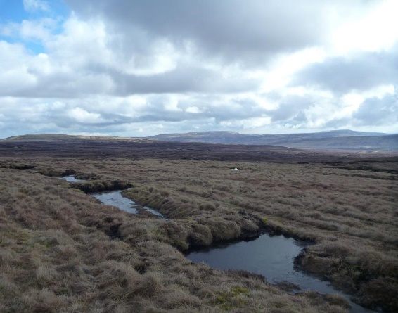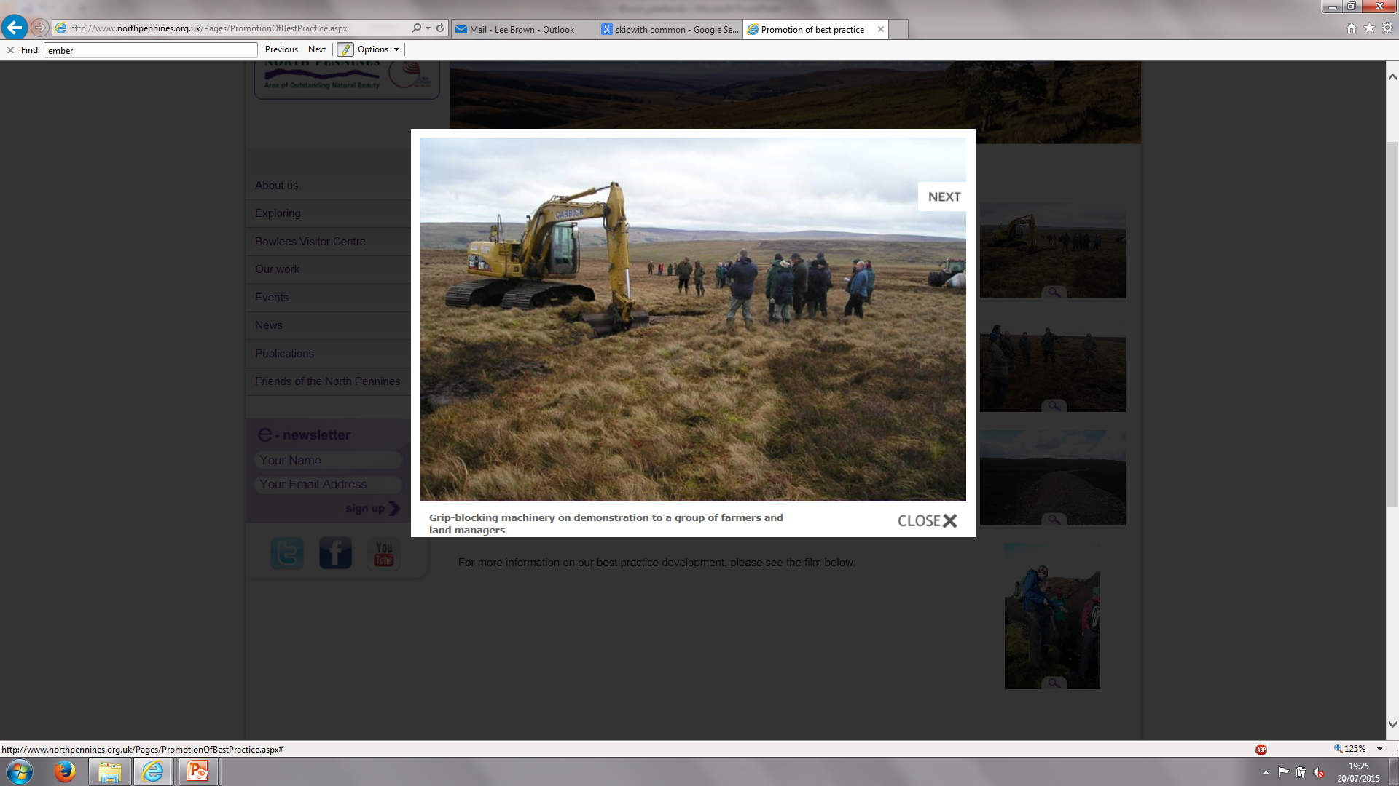

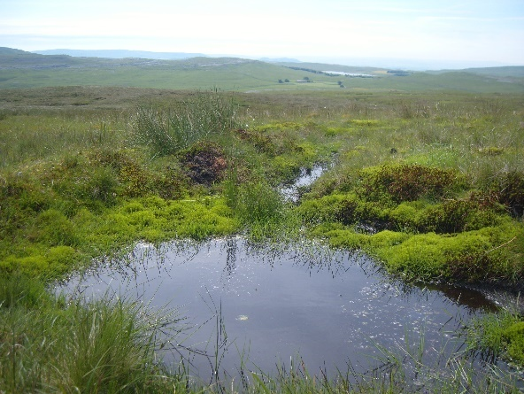

In the UK alone, millions of new peatland ponds have been created by blocking artificial drains, but their biodiversity remains poorly studied and knowledge to guide conservation practice is lacking.

# PROJECT BACKGROUND

Aquatic habitat modifications due to land management, pollution and flow regulation are driving freshwater species declines globally. Peat-dominated wetlands have historically been drained to support extractions for fuel or horticulture and to create land for agriculture, forestry, and infrastructure, also leading to impacts on freshwater species. The important carbon storage role of peatlands has led to large-scale restoration schemes by blocking artificial drains to raise water tables and create ponds. While the responses of hydrological and chemical functioning, terrestrial vegetation and greenhouse gases have been studied after peatland restoration, the additional benefits for aquatic biodiversity need to be evaluated in more detail.

Across the UK, the number of newly-created peatland ponds is now likely to exceed one million. Aquatic communities have been studied in various types of peatland waterbodies, such as old peat cuts and existing ponds on areas of restored peatland yet few have looked specifically at recently created drain-blocked ponds. Various recent studies undertaken by University of Leeds researchers have aimed to investigate how aquatic communities colonise and establish in restored peatland ponds over time, quantify changes in abundances and diversity, and identify associations between physical andchemical variables and ecological communities. These findings can now be incorporated into decision-making when planning further peatland restoration schemes, with aquatic biodiversity considerations included alongside more common drivers such as reducing erosion, reducing drinking water treatment costs and enhancing peatland carbon sinks.

## PROJECT FINDINGS AND IMPLICATIONS

Our research has been undertaken in the Pennine hills of England since 2011, incorporating comparative studies of naturally formed versus restored ponds, and chronosequence studies to gain insights into the long-term colonisation and development of ponds aged from a few months to 15+ years old. Additional studies in the North Pennines at Moor House National Nature Reserve tracked the colonisation of newly formed ponds over the first 18 months of their existence.

2 box plots, one showing relative abundance of invertebrates in ponds on restored peatland, and on showing similar findings for ponds on undisturbed peatlands**🡨** Aquatic invertebrate communities tend to be quite similar in ponds on restored peatlands when compared to naturally-formed ponds where there has been no disturbance from artificial drainage. Chironomidae (non-biting midge larvae)

are typically the dominant invertebrate group whilst Coleoptera (beetles) and Hemiptera (e.g. pond-skaters, water boatmen) are also commonly found. Overall, we have found >80 different species of invertebrates living in restoration ponds. Creating new ponds by blocking artificial drains on peatlands is therefore a highly effective way of providing new aquatic habitats for a range of species.

**↓** The number of species (richness) and the total abundance of invertebrates increases quickly over the first few years of a pond’s existence, then tends to decline slightly as ponds age. Ponds created through peatland restoration will therefore still contribute significantly to aquatic species populations across the UK into the future so long as they do not infill. However, as with other small waterbodies (including natural peatland ponds) they are not monitored routinely and have been examined only minimally as part of previous Countryside Surveys. As the number of ponds on peatlands now likely exceeds the total number of ponds elsewhere in the UK, they must be considered as a major reservoir of aquatic biodiversity. Co-ordinated monitoring should be implemented to inform conservation actions.



Freshwater Biological Association Newsletter cover from summer 2014, showing cells of the algae Saturnella saturnus


**🡪** Newly-formed ponds have been found to host species that are absent from older ponds. For example, the first British record of the green algae species *Saturnella Saturnus* was discovered at Moor House in ponds that were ~15 months old. Five species of Chironomidae were also found in ponds at Moor House shortly after ponds were created, but these disappeared after ponds reached ~6 months age most likely due to competitors or predators establishing populations. Management plans should consider incorporating ponds of different ages across the landscape to maximise aquatic biodiversity. This could be achieved either by staggering their construction, or integrating ponds of different sizes and depths; small, shallow ponds are likely to be ‘reset’ more often by droughts and freezing thus allowing species associated with young ponds to recolonise at different time points.

Pond morphological characteristics (particularly minimum depths) were associated with the composition of invertebrate communities offering some potential for optimising restoration. When blocking artificial drainage channels, hundreds of ponds are often formed at regularly spaced intervals with similar surface areas and bathymetric profiles. Typically, these are steep-sided following the existing ditch cross section but our results showed that some species were found more commonly in ponds with larger surface areas, and larger areas of shallow water (e.g. shelves). These shallows can enhance atmospheric reaeration and therefore maintain elevated dissolved oxygen levels compared to deeper areas, as well as provide refuge from larger aquatic predators. Such pond profiles are often found in natural systems with patterned pond arrangements where asymmetric bathymetry is common. Ponds where ditch sides are reprofiled from box sections into v-shaped channels, or with shallow areas created alongside the existing drain, might provide potential for more biodiversity by offering a variety of depths and habitats. Ponds that are being dug on peatlands outside of artificial drains should also benefit from incorporating morphological diversity.

### WHAT’S NEXT?

Our studies have demonstrated that the biodiversity of restored peatland ponds reflects the temporal stage of development. New ponds colonise very quickly and house novel taxa, and older ponds develop communities similar to naturally-formed ponds. Invertebrates subsequently offer vital sources of food for predators such as dragonflies/damselflies and amphibians, and birds such as Greenshank and Golden Plover. The benefits of pond creation for peatland biodiversity should therefore be considered more widely than our focus on invertebrates and algae. Other aquatic groups such as bacteria and fungi are also likely to be abundant in peatland pools and play major roles influencing water quality and carbon cycling so more studies are needed to quantify the diversity and functional roles of these groups. Restoration and conservation agencies should continue pursuing pond creation and design to optimise trade-offs among peat/vegetation recovery and GHG emissions alongside the array of aquatic biodiversity benefits that can accrue from peatland restoration schemes.

#### REFERENCES

**Suggested reference:** Brown, L.E. & Holden, J. (2023) *Peatland rewetting enhances aquatic biodiversity*. School of Geography briefing note 03. University of Leeds**.**

**Further reading:** Beadle, Holden & Brown. (2023) Landscape-scale peatland rewetting benefits aquatic invertebrate communities. *Biological Conservation* 283: 110116 ([read the paper via this link](https://doi.org/10.1016/j.biocon.2023.110116))

Brown, Ramchunder, Beadle & Holden. (2016). Macroinvertebrate community assembly in pools created during peatland restoration. *Science of the Total Environment* 569-570: 361-372 ([read the paper via this link](https://doi.org/10.1016/j.scitotenv.2016.06.169))

Carter, Beadle, John & Brown. 2015. New observations on *Saturnella saturnus* (Steinecke) Fott: the first British record of a little-known enigmatic ‘green’ alga. *Algological Studies* 149: 61-78 ([read the paper via this link](http://dx.doi.org/10.1127/algol_stud/2015/0247))

**Funders:** Natural Environment Research Council NE/J50001X/1 with additional support from the RSPB and the Esmée Fairbairn Foundation.